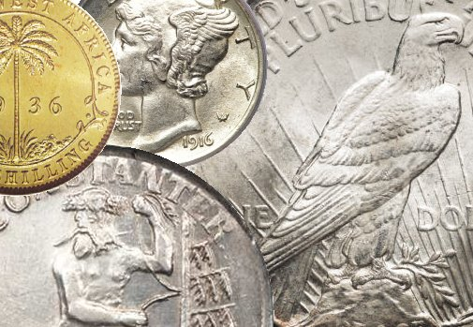
Madison County
Coin Club of Huntsville, Alabama
Show and Tell Comes to the Big Screen and the Newsletter Starting in April 2024
Show and Tell Comes to the Big Screen
And the Newsletter

It has been said by many that one of their favor parts of our club’s meeting is the “Show and Tell” time. This is where you can bring in a coin, pass it around for others to view, and tell a little story about it. With that in mind, the club decided to have an additional spin on “Show And Tell.” You can now have your coin and its story to appear on the big screen during our meeting’s “Show And Tell” time. As an added bonus, it can also appear in our newsletter.

To participate, just email the following information to Mike Campbell :

- Images of your coin (just use your iPhone if you wish.)
- A short story from with a maximum of 10 sentences. (If you need more than 10 sentences, turn your show and tell to a newsletter article!)
- Your name.
- If you wish for your item to appear in the newsletter.
- A maximum of 3 items per month.
Remember, this is in addition to our normal “Show And Tell.” One can still bring a coin and share as always. This is just an added benefit that we hope people can enjoy.

Below are a couple of examples as a go by.

Some Show and Tell from our Members

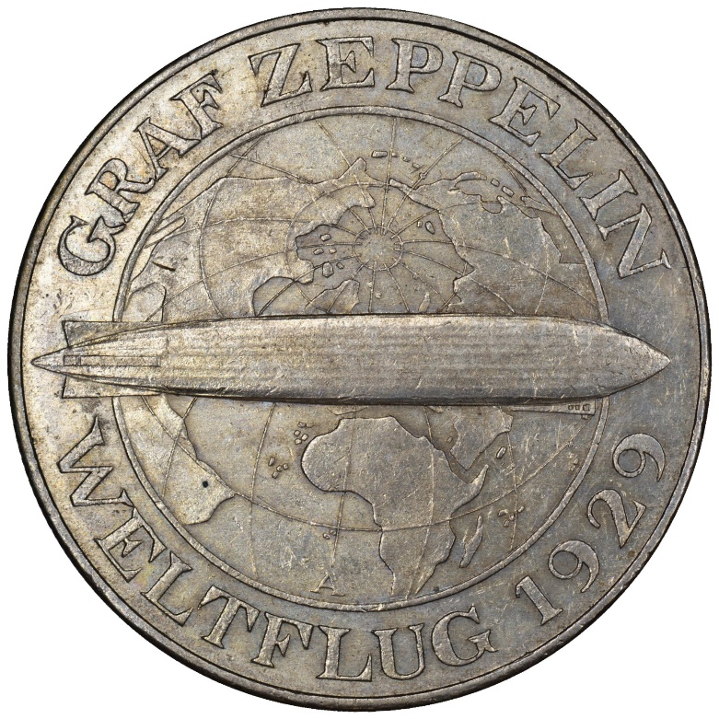
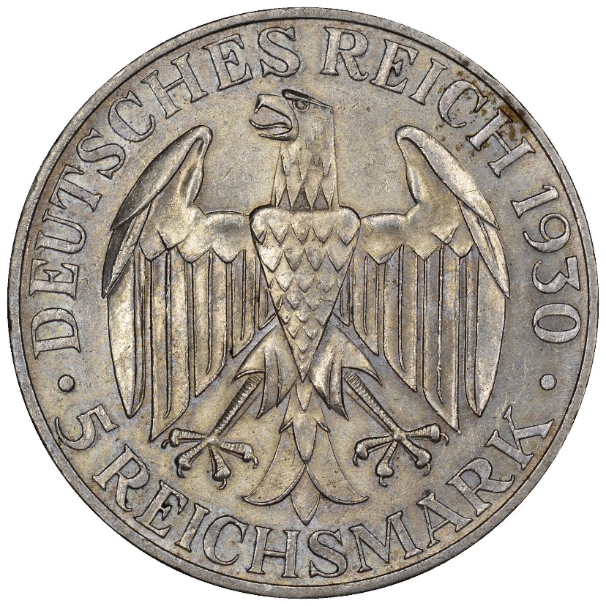
This is a commemorative issue for the 1929 flight of the Graf Zeppelin. It was the first passenger-carrying flight around the world and received massive coverage in the world’s press at the time.
A 1930 German 5 Reichsmark with the "A" mint mark for the Berlin mint.

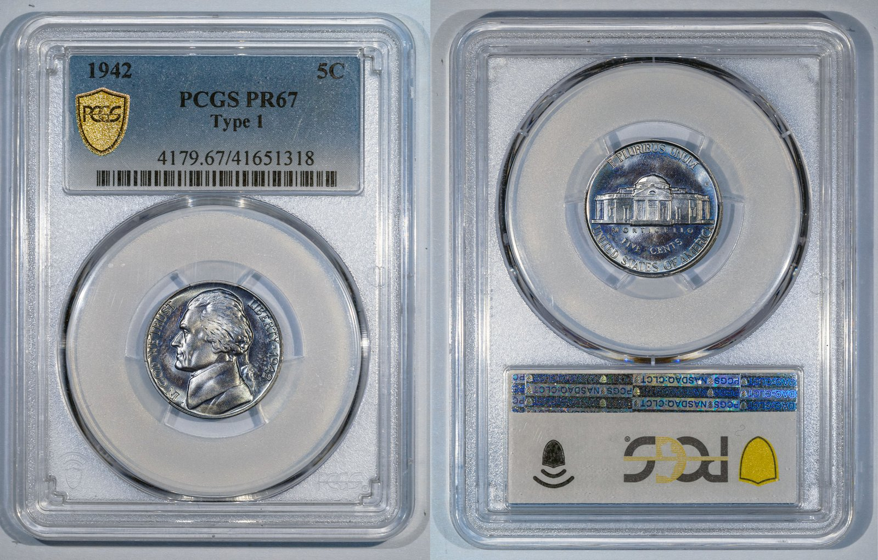

My new proof 1942 nickel is a nice one. – Alfred E. Neuman

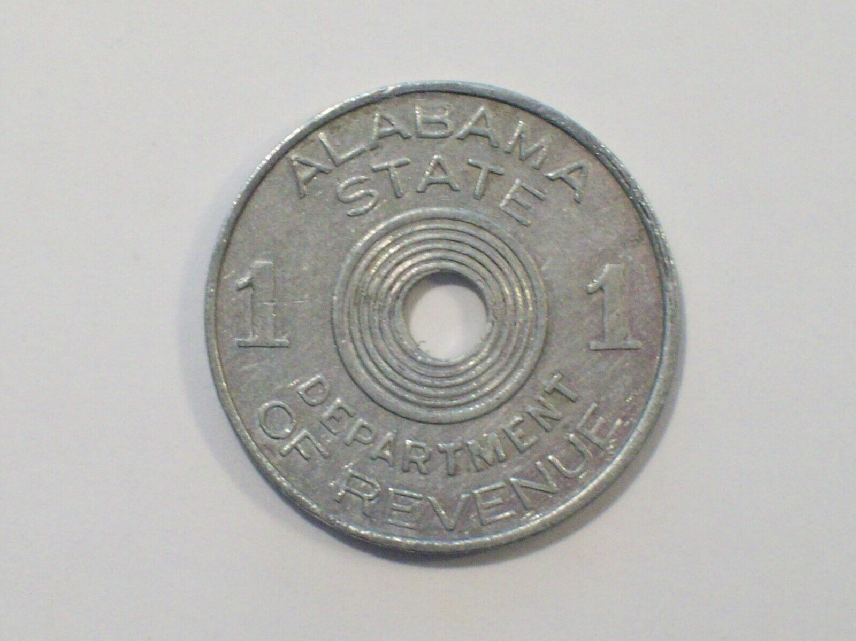

Found this in a roll of dimes. – Alfred E. Neuman

