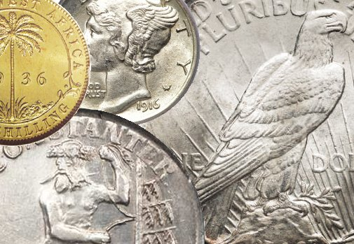
Madison County
Coin Club of Huntsville, Alabama
Volume 24, Issue 2 February 2024

Our next meeting

will be at the
South Huntsville Public Library
7901-L Bailey Cove Rd SE
Huntsville, AL 35802

On Monday

February 19, 2024

from 6:00 – 7:30

Inside This Issue
3 | Some Scenes from our Last Meeting
6 | Finding Rolling Machines in a Surprising Place in London, England
10 | Italian Rupees in Africa
19 | Buyer Beware
20 | Can You Identify this Coin?
22 | The Minute Man
25 | Quiz Time
29 | Club Announcements

